**tuNtw;Gf; FO Cf;Ftpg;G gapw;rp mwpf;if**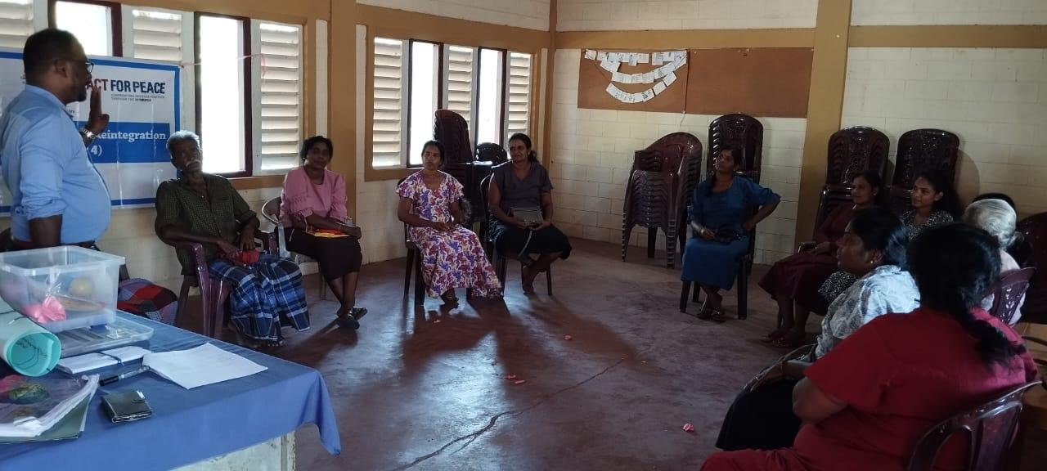

jpfjp – 20.03.2024

Neuk; - 3.00 p.m -5.30 p.m

,lk; - cjaefu; Nkw;F fpuhk mYtyu; kz;lgk;

Nkw;gb tuNtw;Gf; FOTf;fhd Cf;Ftpg;G gapw;rp fye;JiuahlyhdJ 20.03.2024 cjaefu; Nkw;F fpuhk mYttu; gpuptpy; ,lk;ngw;wJ. rpth mz;zh mtu;fs; epfo;tpid jiyik jhq;fp elhj;jpdhu;. ,jpy; tuNtw;Gf;FO cWg;gpdu;fs; kw;Wk; mz;ikapy; ehL jpUk;gpatu;fs; fye;J nfhz;lhu;fs;. tuNtw;Gf; FOf;fspd; cWg;gpdu;fspd; mwpT jpwd;fis tpUj;jp nra;Ak; Nehf;fpy; Nkw;nfhs;sg;gl;l Cf;Ftpg;G gapw;rpapy; Kjyhtjhf mwpKfk; ,lk;ngw;wJ. midtUk; jk;ik mwpKfk; nra;J nfhz;lhu;fs;.

njhlu;e;J tsthsuhf gq;Fgw;wpa rpth mz;zh mtu;fs; rk;gtfw;if xd;wpid gq;Fgw;Weu;fSld; gfpu;e;J nfhz;L njspTgLj;jpdhu;. mLj;J Slipperd track gad;gLj;jp tuNtw;GFO vs;why; vd;d xUtu; Gjpjhf ehL jpUk;Gk; NghJ mtiu vt;thW tuNtw;G nra;a Ntz;Lk;. tuNtw;w gpw;ghL mtuJ Njitfs; vd;d mf; FLk;g efu;e;J nry;tjw;fhd toptiffs; vd;d mtw;iw ehLtjw;fhd gq;Fjhuu;fs; ahuhf cs;shu;fs;. mjw;fhd nraw;ghLfs; vd;d vd;gJ njhlu;ghf fye;Jiuahlg;gl;lJ. me;j gpuptpy; Cf;Ftpg;G vDk; tplaj;ijAk; Nru;f;fyhk; vd tuNtw;Gf; FOtpdu; njuptpj;jhu;fs;.

tuNtw;Gf;FO cWg;gpdu;fis ,U FOf;fshf gpupj;J xU FOtpdu; ehL jpUk;gpatu;fshfTk; kw;iwa FOtpdu; ghjpg;Gf;fis Vw;gLj;Jgtu;fshfTk; gpupf;fg;gl;L ghjpg;Gf;fis Vw;gLj;Jgtu;fs; gY}id cilf;f Ntz;Lk;. ehL jpUk;gpatu;fs; gY}id ghJfhf;f Ntz;Lk;. vd $wg;gl;L tpisahl;L ,lk;ngw;wJ. mjd; %ykhf ,e;jpahtpy; ehL jpUk;gpa xUtiu ,t;thwhd ghjpg;Gf;fspy; ,Ue;J vt;thW ghJfhg;gJ vd;gJ njhlu;ghf njspTgLj;jg;gl;lJ. mj;Jld; tuNtw;Gf; FO cWg;gpdu;fis fz;fis %b ,Uf;Fk; gb $wp rk;gtf;fw;if xd;W $wg;gl;lJ. mjd; $yk; mtu;fs; jkJ czu;Tfs; J}z;lg;gLjhf njuptpj;jhu;fs;. rk;gt fw;ifia Nfl;Fk; NghJ mtiu newpg;gLj;j cjt Ntz;Lk; vDk; kdepiy Vw;gLtjhf $wpdhu;fs;.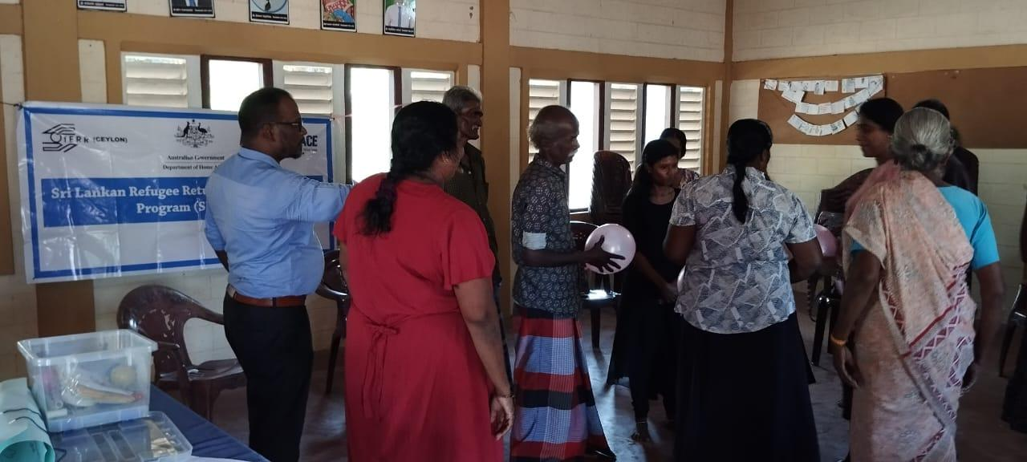

gpd;du; mjpfhu eil vDk; gapw;rp toq;fg;gl;lJ. mjhtJ xt;nthUtUf;Fk; xt;nthU epiyfs; toq;fg;gl;lL mjhtJ MSeu;>fpuhk mYtyu;>gpuNjr nrayhsu;> Kjpatu;> ngz; jiyik jhq;Fk; FLk;gk;>mikr;ru; vd gy;NtW epiyfs; xt;nthUtUf;Fk; toq;fg;gl;L thrpf;fgLk; Nfs;tpfSf;F mt; epiy nghUj;jkhf ,Ue;jhy; xU mb efu;e;J nry;y Ntz;LK; vd njspTgLj;jg;gl;L efu;e;J nrd;w tpjj;jpy; xt;nthUtUk; efu;e;J nrd;wjd; mbg;gilapy; mjpfhu eil eypTw;wtu;fs; vt;tsT J}uk; ghjpf;fg;gLfpwhu;fs; mtu;fis vt;thW ghJfhf;f Ntz;Lk; vd;gJ njhlu;ghf fye;Jiuahlg;gl;lJ.

ehL jpUk;gpa kf;fs; trpf;Fk; gFjpapy; mjhtJ jw;fhyj;jpy; tuNtw;Gf;Fo gFjpapy; cs;s gpur;ridfs; njhlu;ghf fye;Jiuahb kuk; xd;wpid jahu; nra;J mg; gpur;ridf;fhd fhuzq;fs; vd;d mt;thwhd gpur;ridfis vt;thW jPu;j;Jf; nfhs;tJ Nghd;w tplaq;fs; fye;Jiuahlg;gl;L fhl;rpg;gLj;jg;gl;lJ. mj;Jld; ehL jpUk;gpa kf;fSf;F Kiwg;ghL nra;jy; njhlu;ghd tplaq;fs; njspTgLj;jg;gl;lJ. mjhtJ gpur;ridfs; Vw;gLk; gl;rj;jpy; vt;thW Kiwg;ghL nra;tJ vq;F Kiwg;ghL nra;tJ mjdhy; gpur;ridia vt;thW jtpu;f;fyhk; Nghd;w tplaq;fs; njspTgLj;jg;gl;lJ.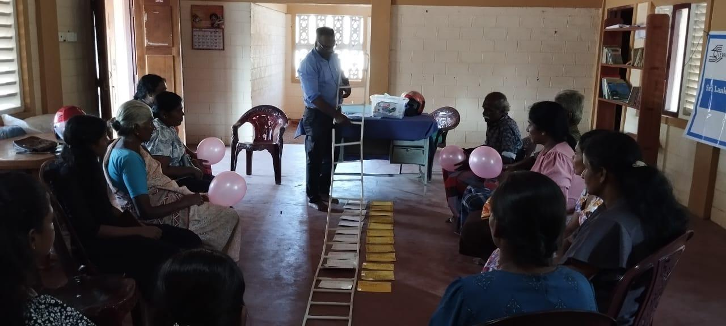

gpd;du; tuNtw;Gf;FO cWg;gpdu;fspilNa ,lk;ngw;w gapw;rpapd; tpisTfs; fw;Wf; nfhz;l ghlq;fs; njhlu;ghf Nfl;fg;gl;lJ. mt;tifapy;>

* ehL jpUk;gpa kf;fSf;F vg;gb topfhl;l Ntz;Lk; vdf; fw;Wf; nfhz;Nlhk;.
* vk;ik ek;gp tUfpd;w xUtupd; gpur;ridia vt;thW jPu;J;Jf; nfhs;s Ntz;Lk;.
* Vidatupd; gpur;ridia mwpe;J jPu;T toq;f Ntz;Lk;.
* ehL jpUk;Gk; kf;fSf;F Njitahd tplaq;fis topfhl;l Ntz;Lk;. Nghd;w tplaq;fs; gfpu;e;J nfhs;sg;gl;lJ.

gpd;G tuNtw;Gf;FO Gjpa epu;thf njupT ,lk;ngw;wJ. mjd; jiytuhf ehL jpUk;gpa re;jpufyh mtu;fs; njupT nra;ag;gl;lhu;. nrayhsuhf Jrhdp mtu;fs; njupT nra;ag;gl;lhu;. nghUshsuhf gfPujp njupT nra;ag;gl;lhu;. ,tu;fspd; jiyikapy; njhlu;e;Jk; tuNtw;Gf;FO rpwg;ghf nraw;gl Ntz;Lk; vdf; nfl;Lf; nfhs;sg;gl;lJld; mLj;j khj fye;Jiuahly; 20.04.2024 ,y; itg;gjhfTk; jPu;khdk; vLf;fg;gl;lJ. gpd;du; gfpu;jh mtu;fspd; ed;wpAiuAld; gapw;rp epiwT ngw;wJ.

njhFg;G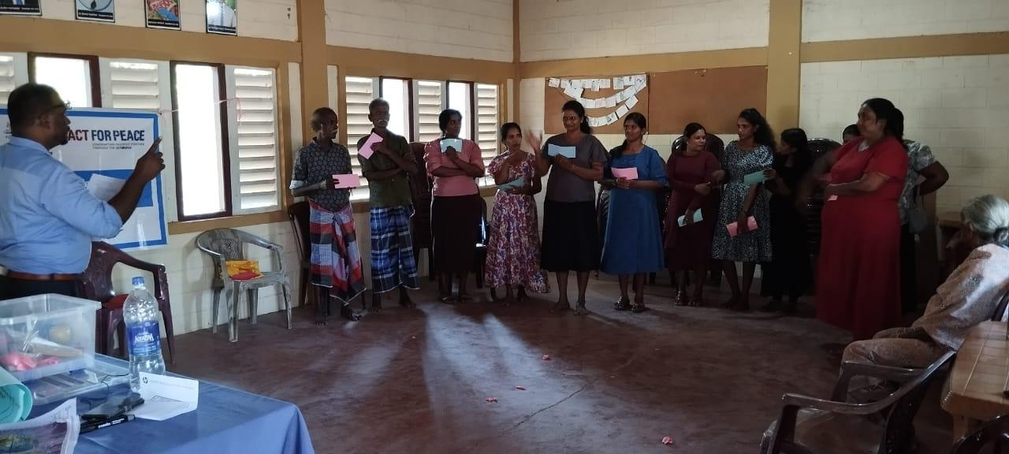

Qh.gfpu;jh